Categories: School Leadership; School Growth; Teaching and Learning

Title NO Change

Meta Title Special Education in Christian Schools

Meta Description:

Alt Tags – Christian School Special Education

Social Media: New data from ACSI sheds light on how Christian schools serve students with special needs.

Image: Maybe reuse the image from here: https://blog.acsi.org/disability-and-inclusion

By the Numbers: How Christian Schools Serve Students with Special Needs
Charlotte A. Marshall

How are Christian schools responding to meet the evolving needs of our students? In order to explore this question, this year’s annual ACSI Tuition and Salary Survey asked ACSI member schools if and how they provide programs and services for students with special needs. With 746 schools responding (for a 29% response rate), the sample of schools is representative of ACSI membership across a number of factors (e.g., geographic location, enrollment size, etc.).

We asked schools specific questions about individualized education program options offered and student participation in those options, namely: Special Education; Gifted/Talented/Honors; Physical Disabilities; and Trade/Vocational programs. Approximately half of responding schools indicated they offered one or more of these options. Table 1 highlights the breakdown of these results by program/service.

Table 1: Special Needs Programs and Student Participation
Individualized Education Programs or Services | Schools with Program or Service | Median Percent of Student Population Participating
Special Education | 35% | 7% of students
Gifted / Talented / Honors | 33% | 11% of students
Physical Disabilities | 6% | 1% of students
Trade / Vocational | 4% | 5% of students

In addition to this data, the survey asked for more specific information on the types of special education programs and services schools provided to students. For the nearly 50% of schools in the sample who offer special education programs and services, the results are shared in Table 2 below.

Table 2: Specific Special Education Programs and Services Offered
Special Education Programs and Services | Responding Schools with Program or Service
Accommodations (HOW learning) | 63%
Modifications (WHAT learning) | 49%
Inclusion Classroom(s) | 31%
Resource Classroom(s) | 29%
Paraprofessional Support | 28%
Assistive Technology | 17%
Self-Contained Classroom(s) | 11%

We also asked questions about the overall availability and accessibility of special education services in ACSI schools, and found that 40% of respondents have students whose needs exceed/are not met by their special education offerings. We also found that of the schools responding to the question (n=128), 55% reported charging additional fees for services. Both of these findings suggest that there is room to improve in Christian schools in terms of meeting students’ special needs, as well as making services and programs more accessible to families regardless of financial ability to pay.

In order to help schools better serve students with special needs, as well as move toward providing tuition equity for these students and their families, ACSI is partnering on a number of initiatives with All Belong, an organization that provides consultation and support for schools seeking to become inclusive communities for learners of all abilities. Readers can expect to see helpful resources, developed through this partnership, rolled out in 2020.

About the Author

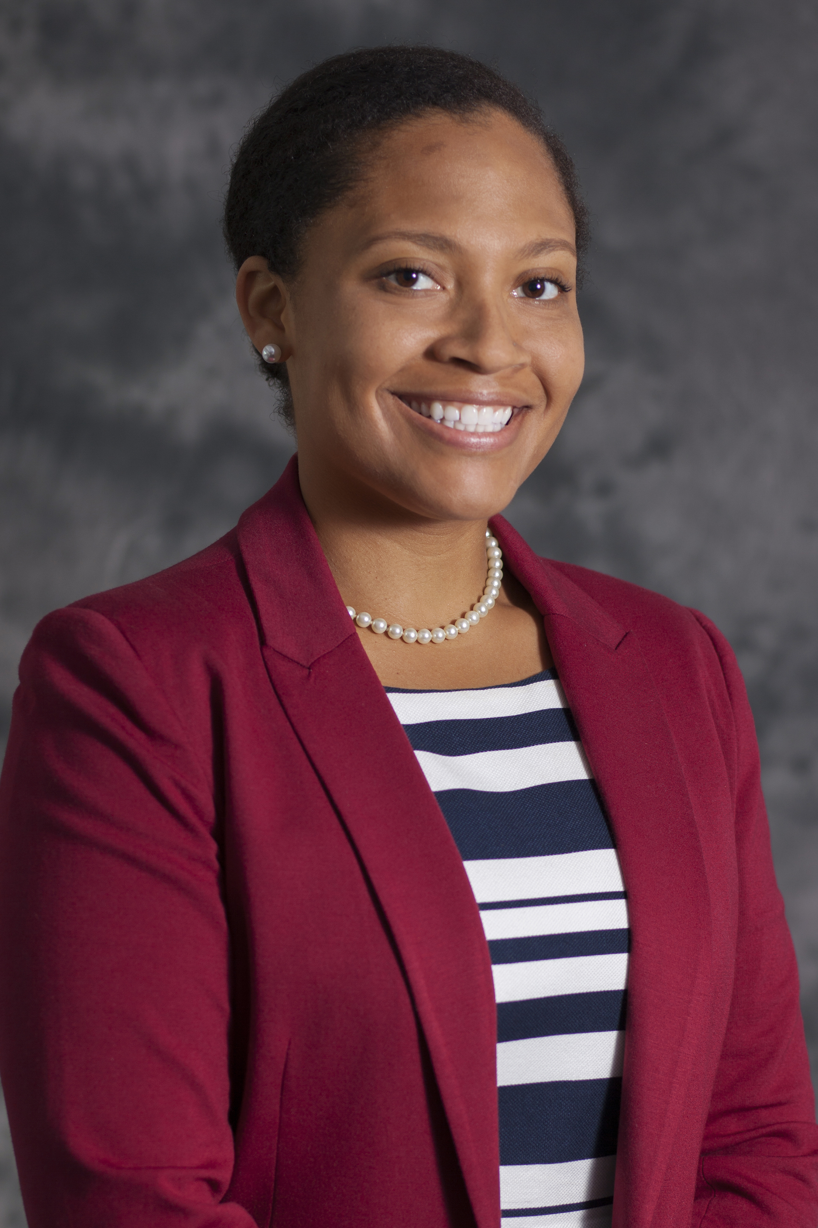 Dr. Charlotte Marshall is the senior researcher at ACSI. Her background includes a decade of research examining individual and community well-being in academic, corporate, and church communities. Deeply rooted in Christian values, she has an ability to lead research projects strategically and empathetically. Prior to joining ACSI, she served as an academic researcher and professor of psychology. She can be reached via email at charlotte_marshall@acsi.org.

Additional Resources

Check out a podcast with Elizabeth Dombrowski from All Belong, as well as the following three blog posts with practical ideas for inclusion in Christian schools: All Belong: Defining Christian Community, Belonging and Disability in the Christian School and Inclusive Education: One Christian School’s Journey.

Community Questions

- Are there students with special needs who would attend your school and/or be better served if their needs could be met?
- If your answer is “yes” to the above, what steps could you take to think about how your school could better serve students?

Community Links:

Nonmembers: https://community.acsi.org/blog-conversations/home

Members: https://community.acsi.org/communities/community-home/digestviewer/viewthread?GroupId=7&MessageKey=1b4e5a38-8cbb-48cb-9fc0-0388cd18238f&CommunityKey=3bc48f54-8a8b-4564-aa35-4f0e5d35173f&tab=digestviewer&ReturnUrl=%2fcommunities%2fcommunity-home%2fdigestviewer%3fcommunitykey%3d3bc48f54-8a8b-4564-aa35-4f0e5d35173f%26tab%3ddigestviewer

